Anindya Basu – A09972316

Aishika Kumar – A12493796

***stickDex***

**Demo:** lipstickdex.firebaseapp.com

**Overview:** stickDex is a web application that allows its users to keep track of various lipsticks. The application helps users asses what is already in their collection as well as what they wish to purchase in the future.

**How it works:**

Our app is hosted on Firebase which we are also using for our database and authentication.

**Files:**

CSS/

-login.css -> contains the CSS for login page

-home.css -> contains the CSS for the home page after login

Fonts/

-contains the various fonts used in the website

IMG/

-contains banner image as well as default lipstick image

JS/

-home.js -> contains javascript for the home page

404.html -> contains HTML for error page

database.rules.json -> contains rules used for Firebase database

firebase.json-> configures which files are published on Firebase

home.html -> contains html for home page

index.html -> contains html for login page

**Comparison to Prototype:**

Our original screens were as shown below:

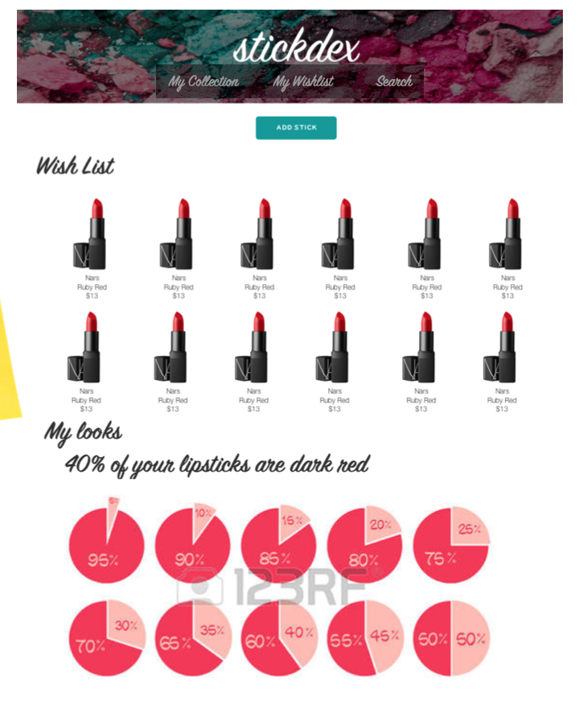

Compared to this, we believe our prototype has come exceedingly close to our original functionality. One thing that is different is the portion of graphs under the “My Looks” category. When designing our prototypes, we knew we wanted to include some sort of useful data here, to help consumers better understand their purchasing habits and also allow them to make more informed decisions in the future. Instead of implementing these pie charts for which we had no real purpose we did the following keeping in mind our two goals:

1. Help consumers better understand their lipstick collection.
2. Help consumers make more informed purchasing decisions in the future.

Our prototype has been upgraded to include the following:

An average amount of money spent on lipsticks so far, as well as an amount showing on average how much a wish listed lipstick costs. In addition to that we show side by side what colors the user already owns, as well as what colors the user wants. This is helpful to users because it shows, at a glance, what colors the user wants and needs, so that even if they can not afford an exact lipstick on their wish list, they can purchase one in a similar color when they are in a store.

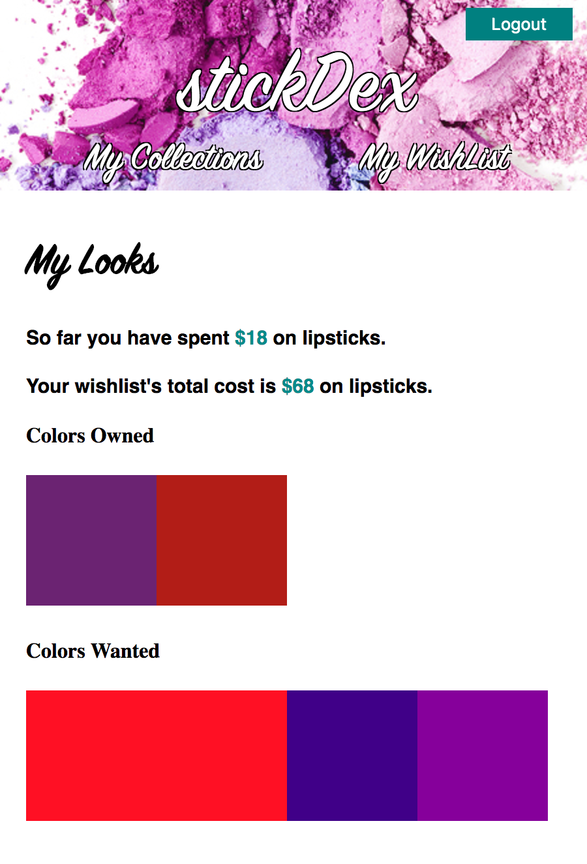

**UI Flow:**

We designed our app to have a single page layout (not including the log-in screen). We did this to ensure ease of use.

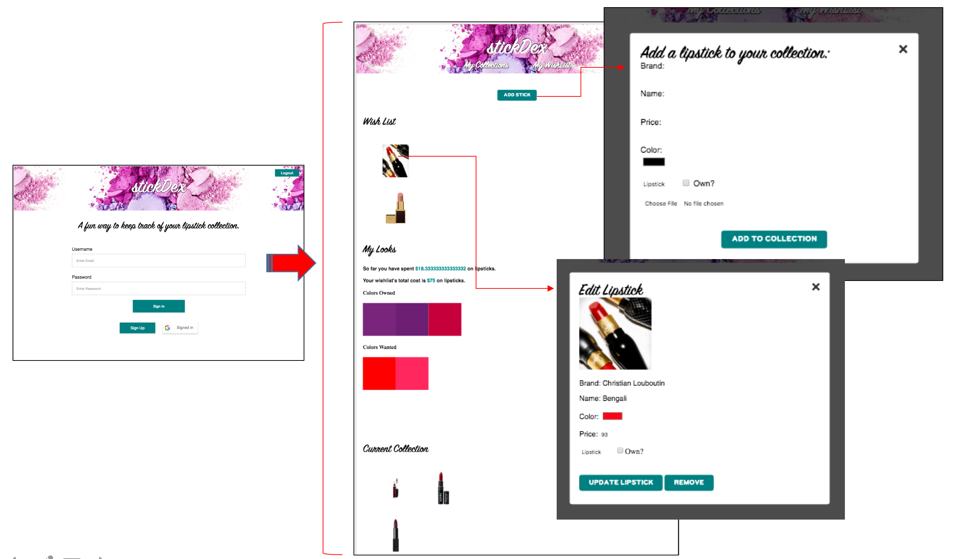

Update Lipstick data by editing fields and then pressing this button

Deletes Lipstick from user account

Add Lipstick to database

Authenticate via Google or Email

**Speed comparisons**

Index.html –

This is the chart when we did a speed test on our app with throttled 3G (slow) on our index page:

First View  
(10.207s)

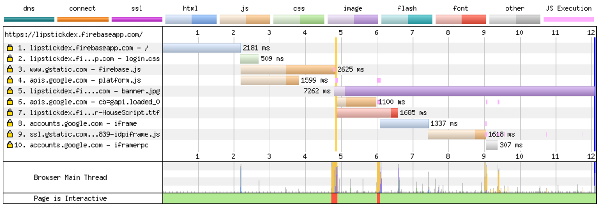

We noticed our banner image was what was giving us the largest time lag so we tried using a much smaller image, this sped up our page by quite a bit:

First View  
(8.748s)

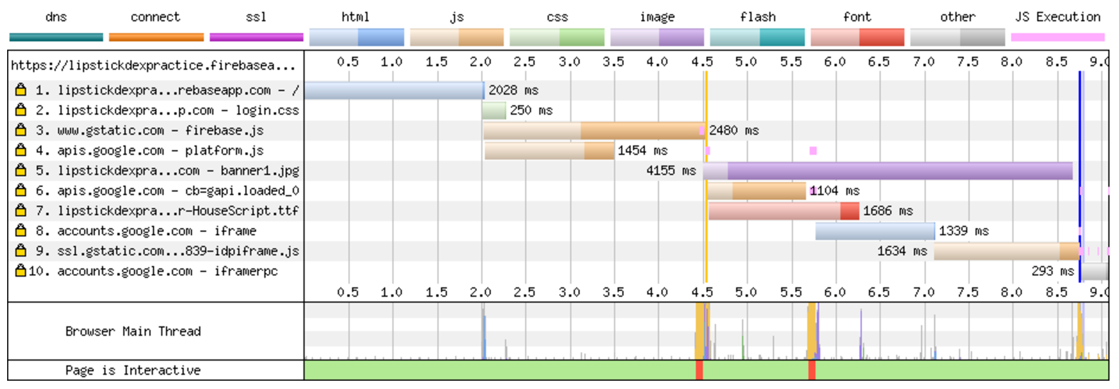

The next page to look at is our home.html page:

Our original page was relatively slow

First View  
(10.065s)

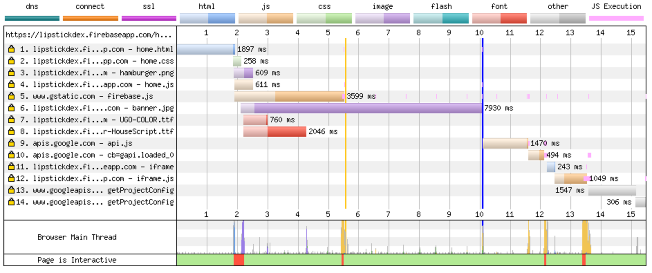

Changing the banner image helped this page speed up quite a bit too:

First View  
(6.953s)

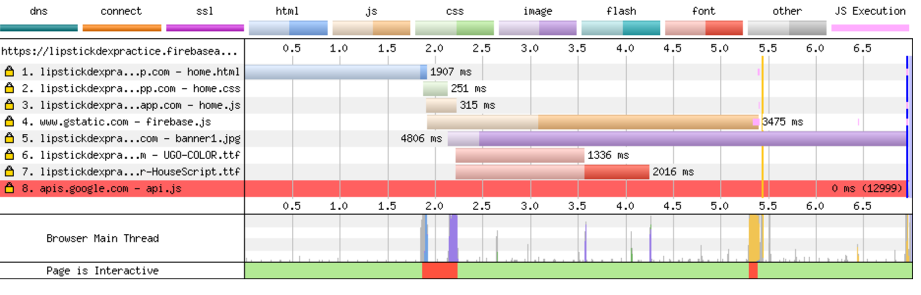

**To Do’s:**

Here we will discuss limitations, caveats, and to do’s.

Our biggest task that we were not able to accomplish with the time we had was making our app work under the 1 second deadline. We did our best to make small optimizations; however, we definitely have a lot more work to do in order to make our app one that can actually be used by users.

We started to look into encoding our images into strings during storage, and loading all our html, css, and javascript files at the same time in order to reduce page load time – however we did not have the time to implement it completely.

Another task is that we would have liked to make the lipstick forms a little more user friendly and error proof. As our app stands now, there are small corner cases where it is possible to break the app if certain fields are not filled out. We would like to fix these issues, given more time.

Thank you

* LipstickDex Team